Inka ABSTRACT
In order to prevent the spread of CORONA virus, everyone must wear a mask during the pandemic. In these tough times of COVID-19 it is necessary to build a model that detects people with and without mask in real-time as it works as a simple precautionary measure to prevent the spread of virus. If deployed correctly, this machine learning technique helps in simplifying the work of frontline warriors and saving their lives. A basic Convolutional Neural Network (CNN) model is built using TensorFlow, Keras, Scikit-learn and OpenCV to make the algorithm as accurate as possible. Javascript API helps in accessing webcam for real-time face mask detection. Since Google Colab runs on web browser it can’t access local hardware like a camera without APIs. The proposed work contains three stages: (i) pre-processing, (ii) Training a CNN and (iii) Real-time classification. The first part is the Pre-processing section, which can be divided into “Grayscale Conversion” of RGB image, ”image resizing and normalization” to avoid false predictions. Then the proposed CNN, classifies faces with and without masks as the output layer of proposed CNN architecture contains two neurons with Softmax activation to classify the same. Categorical cross-entropy is employed as loss function. The proposed model has Validation accuracy of 96%. If anyone in the video stream is not wearing a protective mask a Red coloured rectangle is drawn around the face with a dialog entitled as NO MASK and a Green coloured rectangle is drawn around the face of a person wearing MASK.

1.INTRODUCTION
  - OBJECTIVE:
This paper proposes a method to detect the face mask is put on or not for offices, or any other work place with a lot of people coming to work. We have used convolutional neural network for the same. The model is trained on a real world dataset and tested with live video streaming with a good accuracy. Further the accuracy of the model with different hyper parameters and multiple people at different distance and location of the frame is done.
If anyone in the video stream is not wearing a protective mask and a Red colored rectangle is drawn around the face with a dialog entitled as NO MASK. Similarly a Green color rectangle is drawn around the face of a person wearing MASK.

1.2 PROBLEM STATEMENT:
Millions of people are being infected by Corona Virus throughout the world rapidly. Even WHO recommends to wear a mask in public places to cut the spread of virus as it is contagious. In this paper, a CNN model is proposed for face mask detection. Object detection when applied on faces helps in detecting faces in the image. Face mask detection refers to detecting faces in the image and then classifying each face as with mask or without mask.

2.LITERATURE SURVEY

  - Deep Residual Learning for Image Recognition
AUTHORS: Kaiming He, Xiangyu Zhang, Shaoqing Ren, Jian Sun
ABSTRACT: Deeper neural networks are more difficult to train. We present a residual learning framework to ease the training of networks that are substantially deeper than those used previously. We explicitly reformulate the layers as learning residual functions with reference to the layer inputs, instead of learning unreferenced functions. We provide comprehensive empirical evidence showing that these residual networks are easier to optimize, and can gain accuracy from considerably increased depth. On the ImageNet dataset we evaluate residual nets with a depth of up to 152 layers---8x deeper than VGG nets but still having lower complexity. An ensemble of these residual nets achieves 3.57% error on the ImageNet test set. This result won the 1st place on the ILSVRC 2015 classification task. We also present analysis on CIFAR-10 with 100 and 1000 layers. The depth of representations is of central importance for many visual recognition tasks. Solely due to our extremely deep representations, we obtain a 28% relative improvement on the COCO object detection dataset. Deep residual nets are foundations of our submissions to ILSVRC & COCO 2015 competitions, where we also won the 1st places on the tasks of ImageNet detection, ImageNet localization, COCO detection, and COCO segmentation.

2.2 Detecting Masked Faces in the Wild with LLE-CNNs
AUTHORS: Shiming Ge,Jia Li,Qiting Ye,Zhao Luo
ABSTRACT: Detecting faces with occlusions is a challenging task due to two main reasons: 1) the absence of large datasets of masked faces, and 2) the absence of facial cues from the masked regions. To address these two issues, this paper first introduces a dataset, denoted as MAFA, with 30, 811 Internet images and 35, 806 masked faces. Faces in the dataset have various orientations and occlusion degrees, while at least one part of each face is occluded by mask. Based on this dataset, we further propose LLE-CNNs for masked face detection, which consist of three major modules. The Proposal module first combines two pre-trained CNNs to extract candidate facial regions from the input image and represent them with high dimensional descriptors. After that, the Embedding module is incorporated to turn such descriptors into a similarity-based descriptor by using locally linear embedding (LLE) algorithm and the dictionaries trained on a large pool of synthesized normal faces, masked faces and non-faces. In this manner, many missing facial cues can be largely recovered and the influences of noisy cues introduced by diversified masks can be greatly alleviated. Finally, the Verification module is incorporated to identify candidate facial regions and refine their positions by jointly performing the classification and regression tasks within a unified CNN. Experimental results on the MAFA dataset show that the proposed approach remarkably outperforms 6 state-of-the-arts by at least 15.6%.

2.3 Facial Mask Detection using Semantic Segmentation
AUTHORS: ] T. Meenpal, A. Balakrishnan and A. Verma
ABSTRACT: Face Detection has evolved as a very popular problem in Image processing and Computer Vision. Many new algorithms are being devised using convolutional architectures to make the algorithm as accurate as possible. These convolutional architectures have made it possible to extract even the pixel details. We aim to design a binary face classifier which can detect any face present in the frame irrespective of its alignment. We present a method to generate accurate face segmentation masks from any arbitrary size input image. Beginning from the RGB image of any size, the method uses Predefined Training Weights of VGG - 16 Architecture for feature extraction. Training is performed through Fully Convolutional Networks to semantically segment out the faces present in that image. Gradient Descent is used for training while Binomial Cross Entropy is used as a loss function. Further the output image from the FCN is processed to remove the unwanted noise and avoid the false predictions if any and make bounding box around the faces. Furthermore, proposed model has also shown great results in recognizing non-frontal faces. Along with this it is also able to detect multiple facial masks in a single frame. Experiments were performed on Multi Parsing Human Dataset obtaining mean pixel level accuracy of 93.884 % for the segmented face masks.

2.4 Imagenet classification with deep convolutional neural networks
AUTHORS: A. Krizhevsky I. Sutskever and G. E. Hinton
ABSTRACT: We trained a large, deep convolutional neural network to classify the 1.2 million high-resolution images in the ImageNet LSVRC-2010 contest into the 1000 different classes. On the test data, we achieved top-1 and top-5 error rates of 37.5% and 17.0% which is considerably better than the previous state-of-the-art. The neural network, which has 60 million parameters and 650,000 neurons, consists of five convolutional layers, some of which are followed by max-pooling layers, and three fully-connected layers with a final 1000-way softmax. To make training faster, we used non-saturating neurons and a very efficient GPU implementation of the convolution operation. To reduce overfitting in the fully-connected layers we employed a recently-developed regularization method called “dropout” that proved to be very effective. We also entered a variant of this model in the ILSVRC-2012 competition and achieved a winning top-5 test error rate of 15.3%, compared to 26.2% achieved by the second-best entry.

3.SYSTEM ANALYSIS
3.1 EXISTING SYSTEM:
Government and Public health agencies are recommending face mask as essential measures to keep us safe when venturing into public. To mandate the use of facemask, it becomes essential to devise some technique that enforce individuals to apply a mask before exposure to public places. Face mask detection refers to detect whether a person is wearing a mask or not. In fact, the problem is reverse engineering of face detection where the face is detected using different machine learning algorithms for the purpose of security, authentication and surveillance. Face detection is a key area in the field of Computer Vision and Pattern Recognition. A significant body of research has contributed sophisticated to algorithms for face detection in past.

3.1.1 DISADVANTAGES OF EXISTING SYSTEM:
1.It is difficult to handle person to identify person with mask or without mask in surveillance.

  - PROPOSED SYSTEM:
The proposed CNN, classifies faces with and without masks as the output layer of proposed CNN architecture contains two neurons with Softmax activation to classify the same. Categorical cross-entropy is employed as loss function. The proposed model has Validation accuracy of 96%. If anyone in the video stream is not wearing a protective mask a Red coloured rectangle is drawn around the face with a dialog entitled as NO MASK and a Green coloured rectangle is drawn around the face of a person wearing MASK.

3.2.1 ADVANTAGES OF PROPOSED SYSTEM:
1.The proposed model has Validation accuracy of 96%. If anyone in the video stream is not wearing a protective mask a Red coloured rectangle is drawn around the face with a dialog entitled as NO MASK and a Green coloured rectangle is drawn around the face of a person wearing MASK.

3.3 SYSTEM REQUIREMENTS:
SOFTWARE REQUIREMENTS
The functional requirements or the overall description documents include the product perspective and features, operating system and operating environment, graphics requirements, design constraints and user documentation.
The appropriation of requirements and implementation constraints gives the general overview of the project in regards to what the areas of strength and deficit are and how to tackle them.

- Python idel 3.7 version (or)
- Anaconda 3.7 ( or)
- Jupiter (or)
- Google colab

HARDWARE REQUIREMENTS
Minimum hardware requirements are very dependent on the particular software being developed by a given Enthought Python / Canopy / VS Code user. Applications that need to store large arrays/objects in memory will require more RAM, whereas applications that need to perform numerous calculations or tasks more quickly will require a faster processor.
- Operating system : windows, linux
- Processor : minimum intel i3
- Ram : minimum 4 gb
- Hard disk : minimum 250gb

FUNCTIONAL REQUIREMENTS
1.Data Collection
2.Data Preprocessing
3.Training And Testing
4.Modiling
5.Predicting

3.5 NON FUNCTIONAL REQUIREMENTS
NON-FUNCTIONAL REQUIREMENT (NFR) specifies the quality attribute of a software system. They judge the software system based on Responsiveness, Usability, Security, Portability and other non-functional standards that are critical to the success of the software system. Example of nonfunctional requirement, “how fast does the website load?” Failing to meet non-functional requirements can result in systems that fail to satisfy user needs. Non- functional Requirements allows you to impose constraints or restrictions on the design of the system across the various agile backlogs. Example, the site should load in 3 seconds when the number of simultaneous users are > 10000. Description of non-functional requirements is just as critical as a functional requirement.
- Usability requirement
- Serviceability requirement
- Manageability requirement
- Recoverability requirement
- Security requirement
- Data Integrity requirement
- Capacity requirement
- Availability requirement
- Scalability requirement
- Interoperability requirement
- Reliability requirement
- Maintainability requirement
- Regulatory requirement
- Environmental requirement

3.6 SYSTEM STUDY
FEASIBILITY STUDY

The feasibility of the project is analyzed in this phase and business proposal is put forth with a very general plan for the project and some cost estimates. During system analysis the feasibility study of the proposed system is to be carried out. This is to ensure that the proposed system is not a burden to the company. For feasibility analysis, some understanding of the major requirements for the system is essential.

Three key considerations involved in the feasibility analysis are

- ECONOMICAL FEASIBILITY
- TECHNICAL FEASIBILITY
- SOCIAL FEASIBILITY

ECONOMICAL FEASIBILITY

This study is carried out to check the economic impact that the system will have on the organization. The amount of fund that the company can pour into the research and development of the system is limited. The expenditures must be justified. Thus the developed system as well within the budget and this was achieved because most of the technologies used are freely available. Only the customized products had to be purchased.

TECHNICAL FEASIBILITY

This study is carried out to check the technical feasibility, that is, the technical requirements of the system. Any system developed must not have a high demand on the available technical resources. This will lead to high demands on the available technical resources. This will lead to high demands being placed on the client. The developed system must have a modest requirement, as only minimal or null changes are required for implementing this system.

SOCIAL FEASIBILITY

The aspect of study is to check the level of acceptance of the system by the user. This includes the process of training the user to use the system efficiently. The user must not feel threatened by the system, instead must accept it as a necessity. The level of acceptance by the users solely depends on the methods that are employed to educate the user about the system and to make him familiar with it. His level of confidence must be raised so that he is also able to make some constructive criticism, which is welcomed, as he is the final user of the system.

4.SYSTEM DESIGN
4.1 SYSTEM ARCHITECTURE:

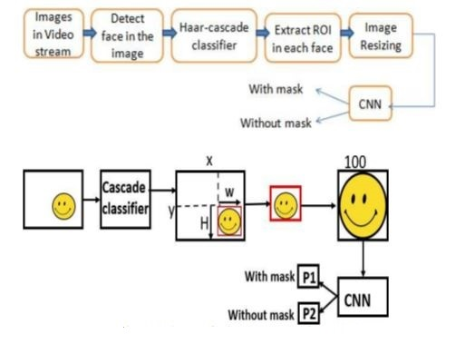

4.2DATA FLOW DIAGRAM:

- The DFD is also called as bubble chart. It is a simple graphical formalism that can be used to represent a system in terms of input data to the system, various processing carried out on this data, and the output data is generated by this system.
- The data flow diagram (DFD) is one of the most important modeling tools. It is used to model the system components. These components are the system process, the data used by the process, an external entity that interacts with the system and the information flows in the system.
- DFD shows how the information moves through the system and how it is modified by a series of transformations. It is a graphical technique that depicts information flow and the transformations that are applied as data moves from input to output.
- DFD is also known as bubble chart. A DFD may be used to represent a system at any level of abstraction. DFD may be partitioned into levels that represent increasing information flow and functional detail.

User

Check

Unauthorized user
Yes NO
Upload Video File

Data Preprocessing

Data Analysis

Model Generation
Build RF,DT,SVM,MNB,LR, GNB &GB Classifiers

Comparison Graph

Create Flask Object

Load Model

User Register

User Login

Upload Patient Details

Predict Result

End process

4.3 UML DIAGRAMS

UML stands for Unified Modeling Language. UML is a standardized general-purpose modeling language in the field of object-oriented software engineering. The standard is managed, and was created by, the Object Management Group.
The goal is for UML to become a common language for creating models of object oriented computer software. In its current form UML is comprised of two major components: a Meta-model and a notation. In the future, some form of method or process may also be added to; or associated with, UML.
The Unified Modeling Language is a standard language for specifying, Visualization, Constructing and documenting the artifacts of software system, as well as for business modeling and other non-software systems.
The UML represents a collection of best engineering practices that have proven successful in the modeling of large and complex systems.
The UML is a very important part of developing objects oriented software and the software development process. The UML uses mostly graphical notations to express the design of software projects.

GOALS:
The Primary goals in the design of the UML are as follows:
- Provide users a ready-to-use, expressive visual modeling Language so that they can develop and exchange meaningful models.
- Provide extendibility and specialization mechanisms to extend the core concepts.
- Be independent of particular programming languages and development process.
- Provide a formal basis for understanding the modeling language.
- Encourage the growth of OO tools market.
- Support higher level development concepts such as collaborations, frameworks, patterns and components.
- Integrate best practices.

Use case diagram:
A use case diagram in the Unified Modeling Language (UML) is a type of behavioral diagram defined by and created from a Use-case analysis. Its purpose is to present a graphical overview of the functionality provided by a system in terms of actors, their goals (represented as use cases), and any dependencies between those use cases. The main purpose of a use case diagram is to show what system functions are performed for which actor. Roles of the actors in the system can be depicted.

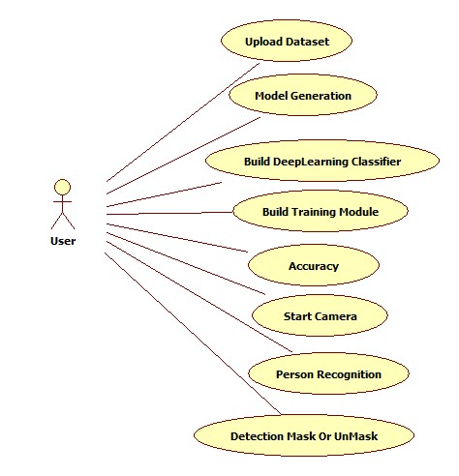

Class diagram:
The class diagram is used to refine the use case diagram and define a detailed design of the system. The class diagram classifies the actors defined in the use case diagram into a set of interrelated classes. The relationship or association between the classes can be either an "is-a" or "has-a" relationship. Each class in the class diagram may be capable of providing certain functionalities. These functionalities provided by the class are termed "methods" of the class. Apart from this, each class may have certain "attributes" that uniquely identify the class.

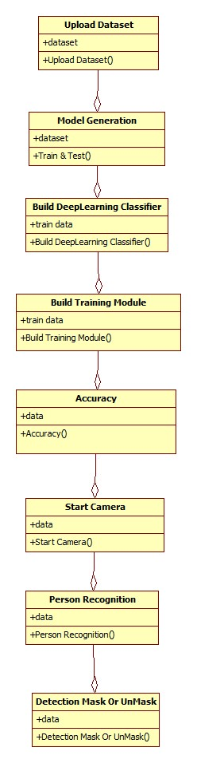

Object diagram:
The object diagram is a special kind of class diagram. An object is an instance of a class. This essentially means that an object represents the state of a class at a given point of time while the system is running. The object diagram captures the state of different classes in the system and their relationships or associations at a given point of time.
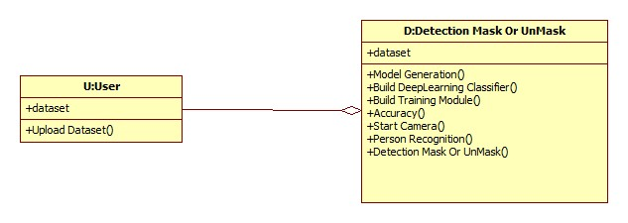

State diagram:
A state diagram, as the name suggests, represents the different states that objects in the system undergo during their life cycle. Objects in the system change states in response to events. In addition to this, a state diagram also captures the transition of the object's state from an initial state to a final state in response to events affecting the system.

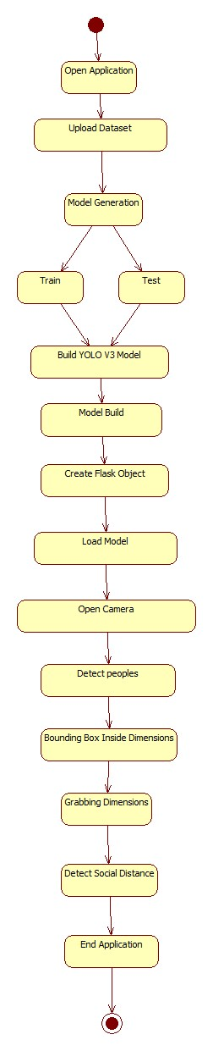
Activity diagram:
The process flows in the system are captured in the activity diagram. Similar to a state diagram, an activity diagram also consists of activities, actions, transitions, initial and final states, and guard conditions.
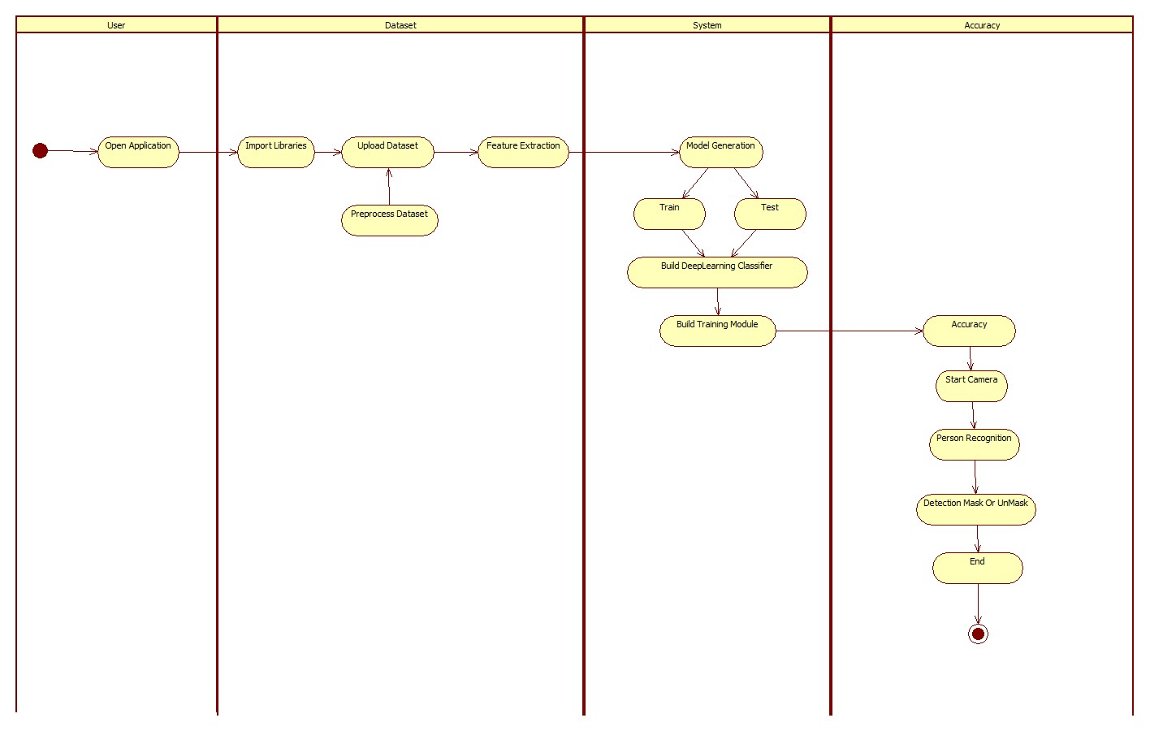
Sequence diagram:
A sequence diagram represents the interaction between different objects in the system. The important aspect of a sequence diagram is that it is time-ordered. This means that the exact sequence of the interactions between the objects is represented step by step. Different objects in the sequence diagram interact with each other by passing "messages".
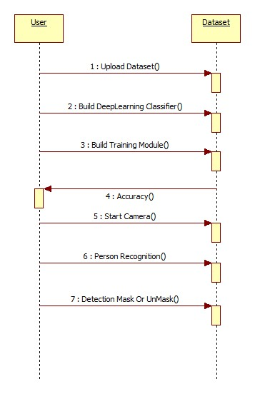

Collaboration diagram:
A collaboration diagram groups together the interactions between different objects. The interactions are listed as numbered interactions that help to trace the sequence of the interactions. The collaboration diagram helps to identify all the possible interactions that each object has with other objects.

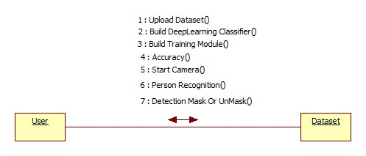

4.3 IMPLEMENTATION:
MODULES:
- Upload Dataset
In this module user upload dataset.
- Build Deep Learning Classifier
In this module Deep learning classifier is build.
- Build Training Module
In this module learning is train to detect mask.
- Accuracy
In this module Accuracy of train model is shown.
- Start Camera
In this module camera is started here.
- Person Recognition
In this module person recognition takes place here.
- Detection Mask Or Un Mask
In this module person is detected with mask or not.

5.SOFTWARE ENVIRONMENT

What is Python :-
Below are some facts about Python.
Python is currently the most widely used multi-purpose, high-level programming language.
Python allows programming in Object-Oriented and Procedural paradigms. Python programs generally are smaller than other programming languages like Java.
Programmers have to type relatively less and indentation requirement of the language, makes them readable all the time.
Python language is being used by almost all tech-giant companies like – Google, Amazon, Facebook, Instagram, Dropbox, Uber… etc.
The biggest strength of Python is huge collection of standard library which can be used for the following –
  - Machine Learning
  - GUI Applications (like Kivy, Tkinter, PyQt etc. )
  - Web frameworks like Django (used by YouTube, Instagram, Dropbox)
  - Image processing (like Opencv, Pillow)
  - Web scraping (like Scrapy, BeautifulSoup, Selenium)
  - Test frameworks
  - Multimedia

Advantages of Python :-
Let’s see how Python dominates over other languages.

1. Extensive Libraries
Python downloads with an extensive library and it contain code for various purposes like regular expressions, documentation-generation, unit-testing, web browsers, threading, databases, CGI, email, image manipulation, and more. So, we don’t have to write the complete code for that manually.

2. Extensible
As we have seen earlier, Python can be extended to other languages. You can write some of your code in languages like C++ or C. This comes in handy, especially in projects.

3. Embeddable
Complimentary to extensibility, Python is embeddable as well. You can put your Python code in your source code of a different language, like C++. This lets us add scripting capabilities to our code in the other language.

4. Improved Productivity
The language’s simplicity and extensive libraries render programmers more productive than languages like Java and C++ do. Also, the fact that you need to write less and get more things done.

5. IOT Opportunities
Since Python forms the basis of new platforms like Raspberry Pi, it finds the future bright for the Internet Of Things. This is a way to connect the language with the real world.

6. Simple and Easy
When working with Java, you may have to create a class to print ‘Hello World’. But in Python, just a print statement will do. It is also quite easy to learn, understand, and code. This is why when people pick up Python, they have a hard time adjusting to other more verbose languages like Java.

7. Readable
Because it is not such a verbose language, reading Python is much like reading English. This is the reason why it is so easy to learn, understand, and code. It also does not need curly braces to define blocks, and indentation is mandatory. This further aids the readability of the code.

8. Object-Oriented
This language supports both the procedural and object-oriented programming paradigms. While functions help us with code reusability, classes and objects let us model the real world. A class allows the encapsulation of data and functions into one.

9. Free and Open-Source
Like we said earlier, Python is freely available. But not only can you download Python for free, but you can also download its source code, make changes to it, and even distribute it. It downloads with an extensive collection of libraries to help you with your tasks.

10. Portable
When you code your project in a language like C++, you may need to make some changes to it if you want to run it on another platform. But it isn’t the same with Python. Here, you need to code only once, and you can run it anywhere. This is called Write Once Run Anywhere (WORA). However, you need to be careful enough not to include any system-dependent features.

11. Interpreted
Lastly, we will say that it is an interpreted language. Since statements are executed one by one, debugging is easier than in compiled languages.
Any doubts till now in the advantages of Python? Mention in the comment section.

Advantages of Python Over Other Languages

1. Less Coding
Almost all of the tasks done in Python requires less coding when the same task is done in other languages. Python also has an awesome standard library support, so you don’t have to search for any third-party libraries to get your job done. This is the reason that many people suggest learning Python to beginners.

2. Affordable
Python is free therefore individuals, small companies or big organizations can leverage the free available resources to build applications. Python is popular and widely used so it gives you better community support.
The 2019 Github annual survey showed us that Python has overtaken Java in the most popular programming language category.

3. Python is for Everyone
Python code can run on any machine whether it is Linux, Mac or Windows. Programmers need to learn different languages for different jobs but with Python, you can professionally build web apps, perform data analysis and machine learning, automate things, do web scraping and also build games and powerful visualizations. It is an all-rounder programming language.

Disadvantages of Python
So far, we’ve seen why Python is a great choice for your project. But if you choose it, you should be aware of its consequences as well. Let’s now see the downsides of choosing Python over another language.

1. Speed Limitations
We have seen that Python code is executed line by line. But since Python is interpreted, it often results in slow execution. This, however, isn’t a problem unless speed is a focal point for the project. In other words, unless high speed is a requirement, the benefits offered by Python are enough to distract us from its speed limitations.

2. Weak in Mobile Computing and Browsers
While it serves as an excellent server-side language, Python is much rarely seen on the client-side. Besides that, it is rarely ever used to implement smartphone-based applications. One such application is called Carbonnelle.
The reason it is not so famous despite the existence of Brython is that it isn’t that secure.

3. Design Restrictions
As you know, Python is dynamically-typed. This means that you don’t need to declare the type of variable while writing the code. It uses duck-typing. But wait, what’s that? Well, it just means that if it looks like a duck, it must be a duck. While this is easy on the programmers during coding, it can raise run-time errors.

4. Underdeveloped Database Access Layers
Compared to more widely used technologies like JDBC (Java DataBase Connectivity) and ODBC (Open DataBase Connectivity), Python’s database access layers are a bit underdeveloped. Consequently, it is less often applied in huge enterprises.

5. Simple
No, we’re not kidding. Python’s simplicity can indeed be a problem. Take my example. I don’t do Java, I’m more of a Python person. To me, its syntax is so simple that the verbosity of Java code seems unnecessary.
This was all about the Advantages and Disadvantages of Python Programming Language.
History of Python : -

What do the alphabet and the programming language Python have in common? Right, both start with ABC. If we are talking about ABC in the Python context, it's clear that the programming language ABC is meant. ABC is a general-purpose programming language and programming environment, which had been developed in the Netherlands, Amsterdam, at the CWI (Centrum Wiskunde &Informatica). The greatest achievement of ABC was to influence the design of Python.Python was conceptualized in the late 1980s. Guido van Rossum worked that time in a project at the CWI, called Amoeba, a distributed operating system. In an interview with Bill Venners¹, Guido van Rossum said: "In the early 1980s, I worked as an implementer on a team building a language called ABC at Centrum voor Wiskunde en Informatica (CWI). I don't know how well people know ABC's influence on Python. I try to mention ABC's influence because I'm indebted to everything I learned during that project and to the people who worked on it."Later on in the same Interview, Guido van Rossum continued: "I remembered all my experience and some of my frustration with ABC. I decided to try to design a simple scripting language that possessed some of ABC's better properties, but without its problems. So I started typing. I created a simple virtual machine, a simple parser, and a simple runtime. I made my own version of the various ABC parts that I liked. I created a basic syntax, used indentation for statement grouping instead of curly braces or begin-end blocks, and developed a small number of powerful data types: a hash table (or dictionary, as we call it), a list, strings, and numbers."
What is Machine Learning : -
Before we take a look at the details of various machine learning methods, let's start by looking at what machine learning is, and what it isn't. Machine learning is often categorized as a subfield of artificial intelligence, but I find that categorization can often be misleading at first brush. The study of machine learning certainly arose from research in this context, but in the data science application of machine learning methods, it's more helpful to think of machine learning as a means of building models of data.
Fundamentally, machine learning involves building mathematical models to help understand data. "Learning" enters the fray when we give these models tunable parameters that can be adapted to observed data; in this way the program can be considered to be "learning" from the data. Once these models have been fit to previously seen data, they can be used to predict and understand aspects of newly observed data. I'll leave to the reader the more philosophical digression regarding the extent to which this type of mathematical, model-based "learning" is similar to the "learning" exhibited by the human brain.Understanding the problem setting in machine learning is essential to using these tools effectively, and so we will start with some broad categorizations of the types of approaches we'll discuss here.
Categories Of Machine Leaning :-
At the most fundamental level, machine learning can be categorized into two main types: supervised learning and unsupervised learning.
Supervised learning involves somehow modeling the relationship between measured features of data and some label associated with the data; once this model is determined, it can be used to apply labels to new, unknown data. This is further subdivided into classification tasks and regression tasks: in classification, the labels are discrete categories, while in regression, the labels are continuous quantities. We will see examples of both types of supervised learning in the following section.
Unsupervised learning involves modeling the features of a dataset without reference to any label, and is often described as "letting the dataset speak for itself." These models include tasks such as clustering and dimensionality reduction. Clustering algorithms identify distinct groups of data, while dimensionality reduction algorithms search for more succinct representations of the data. We will see examples of both types of unsupervised learning in the following section.

Need for Machine Learning
Human beings, at this moment, are the most intelligent and advanced species on earth because they can think, evaluate and solve complex problems. On the other side, AI is still in its initial stage and haven’t surpassed human intelligence in many aspects. Then the question is that what is the need to make machine learn? The most suitable reason for doing this is, “to make decisions, based on data, with efficiency and scale”.
Lately, organizations are investing heavily in newer technologies like Artificial Intelligence, Machine Learning and Deep Learning to get the key information from data to perform several real-world tasks and solve problems. We can call it data-driven decisions taken by machines, particularly to automate the process. These data-driven decisions can be used, instead of using programing logic, in the problems that cannot be programmed inherently. The fact is that we can’t do without human intelligence, but other aspect is that we all need to solve real-world problems with efficiency at a huge scale. That is why the need for machine learning arises.

Challenges in Machines Learning :-

While Machine Learning is rapidly evolving, making significant strides with cybersecurity and autonomous cars, this segment of AI as whole still has a long way to go. The reason behind is that ML has not been able to overcome number of challenges. The challenges that ML is facing currently are −
Quality of data − Having good-quality data for ML algorithms is one of the biggest challenges. Use of low-quality data leads to the problems related to data preprocessing and feature extraction.
Time-Consuming task − Another challenge faced by ML models is the consumption of time especially for data acquisition, feature extraction and retrieval.
Lack of specialist persons − As ML technology is still in its infancy stage, availability of expert resources is a tough job.
No clear objective for formulating business problems − Having no clear objective and well-defined goal for business problems is another key challenge for ML because this technology is not that mature yet.
Issue of overfitting & underfitting − If the model is overfitting or underfitting, it cannot be represented well for the problem.
Curse of dimensionality − Another challenge ML model faces is too many features of data points. This can be a real hindrance.
Difficulty in deployment − Complexity of the ML model makes it quite difficult to be deployed in real life.

Applications of Machines Learning :-

Machine Learning is the most rapidly growing technology and according to researchers we are in the golden year of AI and ML. It is used to solve many real-world complex problems which cannot be solved with traditional approach. Following are some real-world applications of ML −
- Emotion analysis
- Sentiment analysis
- Error detection and prevention
- Weather forecasting and prediction
- Stock market analysis and forecasting
- Speech synthesis
- Speech recognition
- Customer segmentation
- Object recognition
- Fraud detection
- Fraud prevention
- Recommendation of products to customer in online shopping

How to Start Learning Machine Learning?
Arthur Samuel coined the term “Machine Learning” in 1959 and defined it as a “Field of study that gives computers the capability to learn without being explicitly programmed”.
And that was the beginning of Machine Learning! In modern times, Machine Learning is one of the most popular (if not the most!) career choices. According to Indeed, Machine Learning Engineer Is The Best Job of 2019 with a 344% growth and an average base salary of $146,085 per year.
But there is still a lot of doubt about what exactly is Machine Learning and how to start learning it? So this article deals with the Basics of Machine Learning and also the path you can follow to eventually become a full-fledged Machine Learning Engineer. Now let’s get started!!!

How to start learning ML?
This is a rough roadmap you can follow on your way to becoming an insanely talented Machine Learning Engineer. Of course, you can always modify the steps according to your needs to reach your desired end-goal!

Step 1 – Understand the Prerequisites
In case you are a genius, you could start ML directly but normally, there are some prerequisites that you need to know which include Linear Algebra, Multivariate Calculus, Statistics, and Python. And if you don’t know these, never fear! You don’t need a Ph.D. degree in these topics to get started but you do need a basic understanding.

(a) Learn Linear Algebra and Multivariate Calculus
Both Linear Algebra and Multivariate Calculus are important in Machine Learning. However, the extent to which you need them depends on your role as a data scientist. If you are more focused on application heavy machine learning, then you will not be that heavily focused on maths as there are many common libraries available. But if you want to focus on R&D in Machine Learning, then mastery of Linear Algebra and Multivariate Calculus is very important as you will have to implement many ML algorithms from scratch.

(b) Learn Statistics
Data plays a huge role in Machine Learning. In fact, around 80% of your time as an ML expert will be spent collecting and cleaning data. And statistics is a field that handles the collection, analysis, and presentation of data. So it is no surprise that you need to learn it!!!
Some of the key concepts in statistics that are important are Statistical Significance, Probability Distributions, Hypothesis Testing, Regression, etc. Also, Bayesian Thinking is also a very important part of ML which deals with various concepts like Conditional Probability, Priors, and Posteriors, Maximum Likelihood, etc.

(c) Learn Python
Some people prefer to skip Linear Algebra, Multivariate Calculus and Statistics and learn them as they go along with trial and error. But the one thing that you absolutely cannot skip is Python! While there are other languages you can use for Machine Learning like R, Scala, etc. Python is currently the most popular language for ML. In fact, there are many Python libraries that are specifically useful for Artificial Intelligence and Machine Learning such as Keras, TensorFlow, Scikit-learn, etc.
So if you want to learn ML, it’s best if you learn Python! You can do that using various online resources and courses such as Fork Python available Free on GeeksforGeeks.

Step 2 – Learn Various ML Concepts
Now that you are done with the prerequisites, you can move on to actually learning ML (Which is the fun part!!!) It’s best to start with the basics and then move on to the more complicated stuff. Some of the basic concepts in ML are:

(a) Terminologies of Machine Learning
- Model – A model is a specific representation learned from data by applying some machine learning algorithm. A model is also called a hypothesis.
- Feature – A feature is an individual measurable property of the data. A set of numeric features can be conveniently described by a feature vector. Feature vectors are fed as input to the model. For example, in order to predict a fruit, there may be features like color, smell, taste, etc.
- Target (Label) – A target variable or label is the value to be predicted by our model. For the fruit example discussed in the feature section, the label with each set of input would be the name of the fruit like apple, orange, banana, etc.
- Training – The idea is to give a set of inputs(features) and it’s expected outputs(labels), so after training, we will have a model (hypothesis) that will then map new data to one of the categories trained on.
- Prediction – Once our model is ready, it can be fed a set of inputs to which it will provide a predicted output(label).

(b) Types of Machine Learning
- Supervised Learning – This involves learning from a training dataset with labeled data using classification and regression models. This learning process continues until the required level of performance is achieved.
- Unsupervised Learning – This involves using unlabelled data and then finding the underlying structure in the data in order to learn more and more about the data itself using factor and cluster analysis models.
- Semi-supervised Learning – This involves using unlabelled data like Unsupervised Learning with a small amount of labeled data. Using labeled data vastly increases the learning accuracy and is also more cost-effective than Supervised Learning.
- Reinforcement Learning – This involves learning optimal actions through trial and error. So the next action is decided by learning behaviors that are based on the current state and that will maximize the reward in the future.

Advantages of Machine learning :-

1. Easily identifies trends and patterns -
Machine Learning can review large volumes of data and discover specific trends and patterns that would not be apparent to humans. For instance, for an e-commerce website like Amazon, it serves to understand the browsing behaviors and purchase histories of its users to help cater to the right products, deals, and reminders relevant to them. It uses the results to reveal relevant advertisements to them.

2. No human intervention needed (automation)
With ML, you don’t need to babysit your project every step of the way. Since it means giving machines the ability to learn, it lets them make predictions and also improve the algorithms on their own. A common example of this is anti-virus softwares; they learn to filter new threats as they are recognized. ML is also good at recognizing spam.

3. Continuous Improvement
As ML algorithms gain experience, they keep improving in accuracy and efficiency. This lets them make better decisions. Say you need to make a weather forecast model. As the amount of data you have keeps growing, your algorithms learn to make more accurate predictions faster.

4. Handling multi-dimensional and multi-variety data
Machine Learning algorithms are good at handling data that are multi-dimensional and multi-variety, and they can do this in dynamic or uncertain environments.

5. Wide Applications
You could be an e-tailer or a healthcare provider and make ML work for you. Where it does apply, it holds the capability to help deliver a much more personal experience to customers while also targeting the right customers.

Disadvantages of Machine Learning :-

1. Data Acquisition
Machine Learning requires massive data sets to train on, and these should be inclusive/unbiased, and of good quality. There can also be times where they must wait for new data to be generated.

2. Time and Resources
ML needs enough time to let the algorithms learn and develop enough to fulfill their purpose with a considerable amount of accuracy and relevancy. It also needs massive resources to function. This can mean additional requirements of computer power for you.

3. Interpretation of Results
Another major challenge is the ability to accurately interpret results generated by the algorithms. You must also carefully choose the algorithms for your purpose.

4. High error-susceptibility
Machine Learning is autonomous but highly susceptible to errors. Suppose you train an algorithm with data sets small enough to not be inclusive. You end up with biased predictions coming from a biased training set. This leads to irrelevant advertisements being displayed to customers. In the case of ML, such blunders can set off a chain of errors that can go undetected for long periods of time. And when they do get noticed, it takes quite some time to recognize the source of the issue, and even longer to correct it.

Python Development Steps : -
Guido Van Rossum published the first version of Python code (version 0.9.0) at alt.sources in February 1991. This release included already exception handling, functions, and the core data types of list, dict, str and others. It was also object oriented and had a module system.
Python version 1.0 was released in January 1994. The major new features included in this release were the functional programming tools lambda, map, filter and reduce, which Guido Van Rossum never liked.Six and a half years later in October 2000, Python 2.0 was introduced. This release included list comprehensions, a full garbage collector and it was supporting unicode.Python flourished for another 8 years in the versions 2.x before the next major release as Python 3.0 (also known as "Python 3000" and "Py3K") was released. Python 3 is not backwards compatible with Python 2.x. The emphasis in Python 3 had been on the removal of duplicate programming constructs and modules, thus fulfilling or coming close to fulfilling the 13th law of the Zen of Python: "There should be one -- and preferably only one -- obvious way to do it."Some changes in Python 7.3:
- Print is now a function
- Views and iterators instead of lists
- The rules for ordering comparisons have been simplified. E.g. a heterogeneous list cannot be sorted, because all the elements of a list must be comparable to each other.
- There is only one integer type left, i.e. int. long is int as well.
- The division of two integers returns a float instead of an integer. "//" can be used to have the "old" behaviour.
- Text Vs. Data Instead Of Unicode Vs. 8-bit
Purpose :-
We demonstrated that our approach enables successful segmentation of intra-retinal layers—even with low-quality images containing speckle noise, low contrast, and different intensity ranges throughout—with the assistance of the ANIS feature.
Python
Python is an interpreted high-level programming language for general-purpose programming. Created by Guido van Rossum and first released in 1991, Python has a design philosophy that emphasizes code readability, notably using significant whitespace.
Python features a dynamic type system and automatic memory management. It supports multiple programming paradigms, including object-oriented, imperative, functional and procedural, and has a large and comprehensive standard library.
- Python is Interpreted − Python is processed at runtime by the interpreter. You do not need to compile your program before executing it. This is similar to PERL and PHP.
- Python is Interactive − you can actually sit at a Python prompt and interact with the interpreter directly to write your programs.
Python also acknowledges that speed of development is important. Readable and terse code is part of this, and so is access to powerful constructs that avoid tedious repetition of code. Maintainability also ties into this may be an all but useless metric, but it does say something about how much code you have to scan, read and/or understand to troubleshoot problems or tweak behaviors. This speed of development, the ease with which a programmer of other languages can pick up basic Python skills and the huge standard library is key to another area where Python excels. All its tools have been quick to implement, saved a lot of time, and several of them have later been patched and updated by people with no Python background - without breaking.
Modules Used in Project :-
Tensorflow
TensorFlow is a free and open-source software library for dataflow and differentiable programming across a range of tasks. It is a symbolic math library, and is also used for machine learning applications such as neural networks. It is used for both research and production at Google.‍
TensorFlow was developed by the Google Brain team for internal Google use. It was released under the Apache 2.0 open-source license on November 9, 2015.
Numpy
Numpy is a general-purpose array-processing package. It provides a high-performance multidimensional array object, and tools for working with these arrays.
It is the fundamental package for scientific computing with Python. It contains various features including these important ones:
- A powerful N-dimensional array object
- Sophisticated (broadcasting) functions
- Tools for integrating C/C++ and Fortran code
- Useful linear algebra, Fourier transform, and random number capabilities
Besides its obvious scientific uses, Numpy can also be used as an efficient multi-dimensional container of generic data. Arbitrary data-types can be defined using Numpy which allows Numpy to seamlessly and speedily integrate with a wide variety of databases.
Pandas
Pandas is an open-source Python Library providing high-performance data manipulation and analysis tool using its powerful data structures. Python was majorly used for data munging and preparation. It had very little contribution towards data analysis. Pandas solved this problem. Using Pandas, we can accomplish five typical steps in the processing and analysis of data, regardless of the origin of data load, prepare, manipulate, model, and analyze. Python with Pandas is used in a wide range of fields including academic and commercial domains including finance, economics, Statistics, analytics, etc.
Matplotlib
Matplotlib is a Python 2D plotting library which produces publication quality figures in a variety of hardcopy formats and interactive environments across platforms. Matplotlib can be used in Python scripts, the Python and IPython shells, the Jupyter Notebook, web application servers, and four graphical user interface toolkits. Matplotlib tries to make easy things easy and hard things possible. You can generate plots, histograms, power spectra, bar charts, error charts, scatter plots, etc., with just a few lines of code. For examples, see the sample plots and thumbnail gallery.
For simple plotting the pyplot module provides a MATLAB-like interface, particularly when combined with IPython. For the power user, you have full control of line styles, font properties, axes properties, etc, via an object oriented interface or via a set of functions familiar to MATLAB users.
Scikit – learn
Scikit-learn provides a range of supervised and unsupervised learning algorithms via a consistent interface in Python. It is licensed under a permissive simplified BSD license and is distributed under many Linux distributions, encouraging academic and commercial use. Python
Python is an interpreted high-level programming language for general-purpose programming. Created by Guido van Rossum and first released in 1991, Python has a design philosophy that emphasizes code readability, notably using significant whitespace.
Python features a dynamic type system and automatic memory management. It supports multiple programming paradigms, including object-oriented, imperative, functional and procedural, and has a large and comprehensive standard library.
- Python is Interpreted − Python is processed at runtime by the interpreter. You do not need to compile your program before executing it. This is similar to PERL and PHP.
- Python is Interactive − you can actually sit at a Python prompt and interact with the interpreter directly to write your programs.
Python also acknowledges that speed of development is important. Readable and terse code is part of this, and so is access to powerful constructs that avoid tedious repetition of code. Maintainability also ties into this may be an all but useless metric, but it does say something about how much code you have to scan, read and/or understand to troubleshoot problems or tweak behaviors. This speed of development, the ease with which a programmer of other languages can pick up basic Python skills and the huge standard library is key to another area where Python excels. All its tools have been quick to implement, saved a lot of time, and several of them have later been patched and updated by people with no Python background - without breaking.
Install Python Step-by-Step in Windows and Mac :
Python a versatile programming language doesn’t come pre-installed on your computer devices. Python was first released in the year 1991 and until today it is a very popular high-level programming language. Its style philosophy emphasizes code readability with its notable use of great whitespace.
The object-oriented approach and language construct provided by Python enables programmers to write both clear and logical code for projects. This software does not come pre-packaged with Windows.

How to Install Python on Windows and Mac :

There have been several updates in the Python version over the years. The question is how to install Python? It might be confusing for the beginner who is willing to start learning Python but this tutorial will solve your query. The latest or the newest version of Python is version 3.7.4 or in other words, it is Python 3.
Note: The python version 3.7.4 cannot be used on Windows XP or earlier devices.

Before you start with the installation process of Python. First, you need to know about your System Requirements. Based on your system type i.e. operating system and based processor, you must download the python version. My system type is a Windows 64-bit operating system. So the steps below are to install python version 3.7.4 on Windows 7 device or to install Python 3. Download the Python Cheatsheet here.The steps on how to install Python on Windows 10, 8 and 7 are divided into 4 parts to help understand better.

Download the Correct version into the system

Step 1: Go to the official site to download and install python using Google Chrome or any other web browser. OR Click on the following link: https://www.python.org

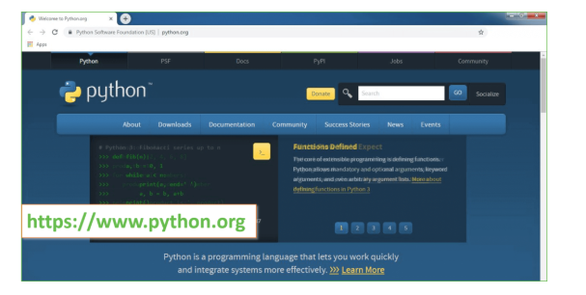
Now, check for the latest and the correct version for your operating system.
Step 2: Click on the Download Tab.
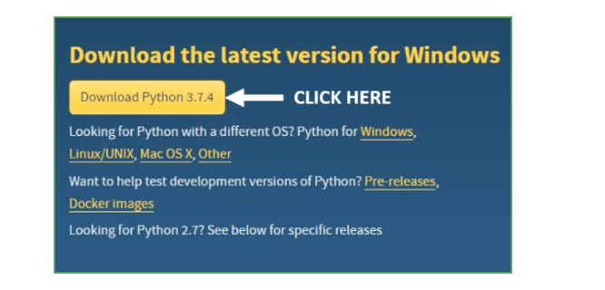
Step 3: You can either select the Download Python for windows 3.7.4 button in Yellow Color or you can scroll further down and click on download with respective to their version. Here, we are downloading the most recent python version for windows 3.7.4
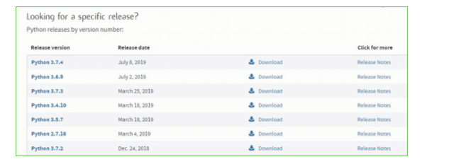
Step 4: Scroll down the page until you find the Files option.

Step 5: Here you see a different version of python along with the operating system.

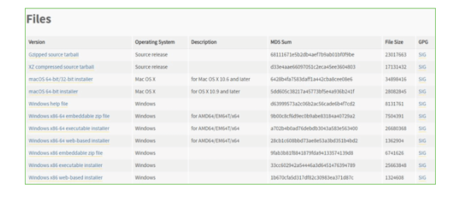

• To download Windows 32-bit python, you can select any one from the three options: Windows x86 embeddable zip file, Windows x86 executable installer or Windows x86 web-based installer.
•To download Windows 64-bit python, you can select any one from the three options: Windows x86-64 embeddable zip file, Windows x86-64 executable installer or Windows x86-64 web-based installer.
Here we will install Windows x86-64 web-based installer. Here your first part regarding which version of python is to be downloaded is completed. Now we move ahead with the second part in installing python i.e. Installation
Note: To know the changes or updates that are made in the version you can click on the Release Note Option.

Installation of Python
Step 1: Go to Download and Open the downloaded python version to carry out the installation process.
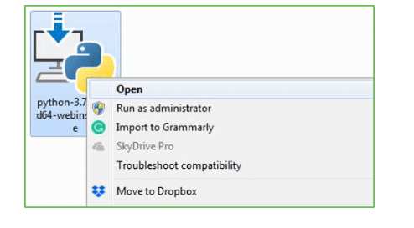
Step 2: Before you click on Install Now, Make sure to put a tick on Add Python 3.7 to PATH.

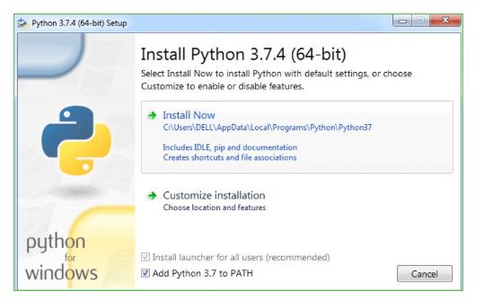

Step 3: Click on Install NOW After the installation is successful. Click on Close.

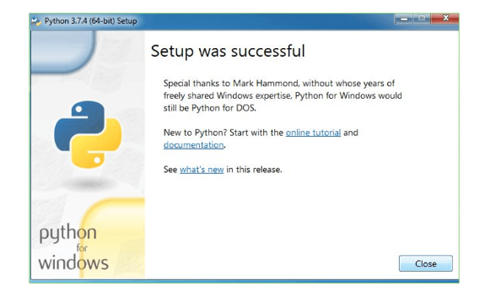

With these above three steps on python installation, you have successfully and correctly installed Python. Now is the time to verify the installation.
Note: The installation process might take a couple of minutes.

Verify the Python Installation
Step 1: Click on Start
Step 2: In the Windows Run Command, type “cmd”.

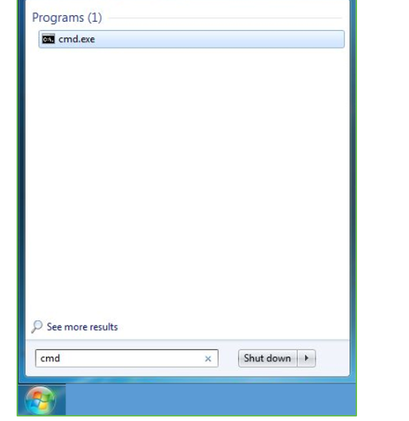
Step 3: Open the Command prompt option.
Step 4: Let us test whether the python is correctly installed. Type python –V and press Enter.

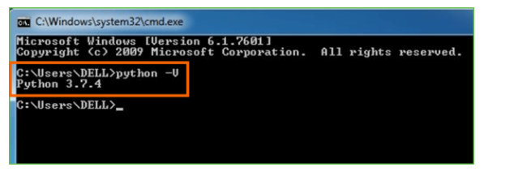
Step 5: You will get the answer as 3.7.4
Note: If you have any of the earlier versions of Python already installed. You must first uninstall the earlier version and then install the new one.

Check how the Python IDLE works
Step 1: Click on Start
Step 2: In the Windows Run command, type “python idle”.
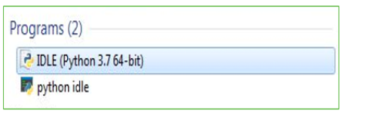
Step 3: Click on IDLE (Python 3.7 64-bit) and launch the program
Step 4: To go ahead with working in IDLE you must first save the file. Click on File > Click on Save

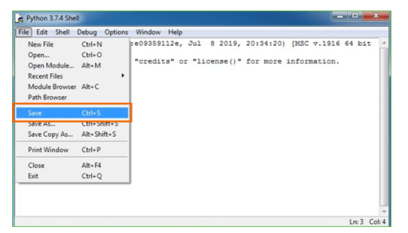
Step 5: Name the file and save as type should be Python files. Click on SAVE. Here I have named the files as Hey World.
Step 6: Now for e.g. enter print
6.SYSTEM TEST
The purpose of testing is to discover errors. Testing is the process of trying to discover every conceivable fault or weakness in a work product. It provides a way to check the functionality of components, sub assemblies, assemblies and/or a finished product It is the process of exercising software with the intent of ensuring that the Software system meets its requirements and user expectations and does not fail in an unacceptable manner. There are various types of test. Each test type addresses a specific testing requirement.

TYPES OF TESTS

Unit testing
Unit testing involves the design of test cases that validate that the internal program logic is functioning properly, and that program inputs produce valid outputs. All decision branches and internal code flow should be validated. It is the testing of individual software units of the application .it is done after the completion of an individual unit before integration. This is a structural testing, that relies on knowledge of its construction and is invasive. Unit tests perform basic tests at component level and test a specific business process, application, and/or system configuration. Unit tests ensure that each unique path of a business process performs accurately to the documented specifications and contains clearly defined inputs and expected results.

Integration testing
Integration tests are designed to test integrated software components to determine if they actually run as one program. Testing is event driven and is more concerned with the basic outcome of screens or fields. Integration tests demonstrate that although the components were individually satisfaction, as shown by successfully unit testing, the combination of components is correct and consistent. Integration testing is specifically aimed at exposing the problems that arise from the combination of components.

Functional test

Functional tests provide systematic demonstrations that functions tested are available as specified by the business and technical requirements, system documentation, and user manuals.
Functional testing is centered on the following items:
Valid Input : identified classes of valid input must be accepted.
Invalid Input : identified classes of invalid input must be rejected.
Functions : identified functions must be exercised.
Output : identified classes of application outputs must be exercised.
Systems/Procedures : interfacing systems or procedures must be invoked.
Organization and preparation of functional tests is focused on requirements, key functions, or special test cases. In addition, systematic coverage pertaining to identify Business process flows; data fields, predefined processes, and successive processes must be considered for testing. Before functional testing is complete, additional tests are identified and the effective value of current tests is determined.

System Test
System testing ensures that the entire integrated software system meets requirements. It tests a configuration to ensure known and predictable results. An example of system testing is the configuration oriented system integration test. System testing is based on process descriptions and flows, emphasizing pre-driven process links and integration points.

White Box Testing
White Box Testing is a testing in which in which the software tester has knowledge of the inner workings, structure and language of the software, or at least its purpose. It is purpose. It is used to test areas that cannot be reached from a black box level.

Black Box Testing

Black Box Testing is testing the software without any knowledge of the inner workings, structure or language of the module being tested. Black box tests, as most other kinds of tests, must be written from a definitive source document, such as specification or requirements document, such as specification or requirements document. It is a testing in which the software under test is treated, as a black box .you cannot “see” into it. The test provides inputs and responds to outputs without considering how the software works.
Unit Testing
Unit testing is usually conducted as part of a combined code and unit test phase of the software lifecycle, although it is not uncommon for coding and unit testing to be conducted as two distinct phases.
Test strategy and approach
Field testing will be performed manually and functional tests will be written in detail.
Test objectives
- All field entries must work properly.
- Pages must be activated from the identified link.
- The entry screen, messages and responses must not be delayed.

Features to be tested
- Verify that the entries are of the correct format
- No duplicate entries should be allowed
- All links should take the user to the correct page.

Integration Testing
Software integration testing is the incremental integration testing of two or more integrated software components on a single platform to produce failures caused by interface defects.
The task of the integration test is to check that components or software applications, e.g. components in a software system or – one step up – software applications at the company level – interact without error.
Test Results: All the test cases mentioned above passed successfully. No defects encountered.

Acceptance Testing
User Acceptance Testing is a critical phase of any project and requires significant participation by the end user. It also ensures that the system meets the functional requirements.
Test Results: All the test cases mentioned above passed successfully. No defects encountered.
Test Cases
USER REQUIREMENTS:
- Home
Use case ID | Face Mask Detection Using Deep Learning
Use case Name | Home button
Description | Display home page of application
Primary actor | User
Precondition | User must open application
Post condition | Display the Home Page of an application
Frequency of Use case | Many times
Alternative use case | N/A
Use case Diagrams
Attachments | N/A

7.SCREENSHOTS

8.CONCLUSION
Face detection is performed and Using the two labels which were declared one for color and the other for title, faces in the image are classified as with mask or without mask. Accuracy percentage is displayed in white color at the top of the image.

FUTURE ENHANCEMENTS

The present model proposed gives great accuracy for single face with and without mask. For multiple faces also it gives quite good accuracy. It works easily on any mobile device just by switching on the video stream, with no external hardware requirement. Further we will work for improving the accuracy for multiple face mask detection, to classify the faces into three categories that is, With mask, without mask, Improper mask instead of just the two with and without mask class by adding datasets with images of people wearing masks not covering their noses properly and also to detect the masked face using the FaceNet model of Convolutional Neural Network like in so as to further improve our model and add marking attendance feature in it by detecting the face even when the mask is on.

9. REFERENCES
Journals:
- Programming Python, Mark Lutz
- Head First Python, Paul Barry
- Core Python Programming, R. Nageswara Rao
- Learning with Python, Allen B. Downey

BOOKS:
[1] K. He X. Zhang S. Ren and J. Sun "Deep residual learning for image recognition" 2016 IEEE Conference on Computer Vision and Pattern Recognition (CVPR) pp. 770-778 2016.
[2 ] K. Li G. Ding and H. Wang "L-fcn: A lightweight fully convolutional network for biomedical semantic segmentation" 2018 IEEE International Conference on Bioinformatics and Biomedicine (BIBM) pp. 2363-2367 Dec 2018.
[3] S. Ge, J. Li, Q. Ye and Z. Luo, "Detecting Masked Faces in the Wild with LLE-CNNs," 2017 IEEE Conference on Computer Vision and Pattern Recognition (CVPR), Honolulu, HI, 2017, pp. 426-434, doi: 10.1109/CVPR.2017.53.
WEBSITES:
- https://www.w3schools.com/python/
- https://www.tutorialspoint.com/python/index.htm
- https://www.javatpoint.com/python-tutorial
- https://www.learnpython.org/
- https://www.pythontutorial.net/

